# File permissions in Linux

## Project description

This project demonstrates the effective use of Linux commands to update file permissions within the projects directory. By implementing proper file access controls, the project ensures the security of organizational data, contributing to a robust and protected data environment.

## Check file and directory details

The following line of commands are use to check the directory and to enter the project directory

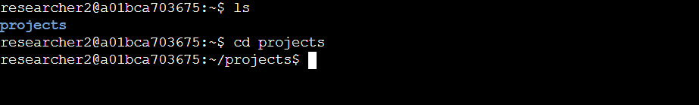

The first line of command ls is used list the file and folders of the directory.

Next step cd projects is used to enter the project folder.

## Describe the permissions string

The owner of the file is classified as user(u), group(g) and other(o).

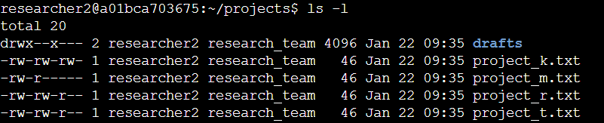

In the above snip the command ls -l is used display the access permission of each file and folder in that current directory. For an example the project_k.txt has the following permission _rw_rw_rw_ the first character indicate the type if “_” means a file or if “d” means a folder .The next 3 character will indicate access the owner type of user (u) ,the next 3 will be for group(g) and the last 3 is for other(o).

**In our case :**

User(u)- can read and write

Group(g)- can read and write

Other(0)- can read and write

## Change file permissions

The example taken in the above project_k.txt has access of write to other. In our case we don’t want the access of other to write.

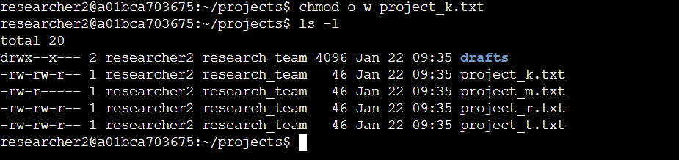

To update(remove access of write of other) chmod o-w project_k.txt command is used. In o-w “o” represent other and “w” represent access type write in order to remove the access of write “-“ is used .In case of adding access “+” is used.

After changing the access to recheck ls -l is used to display the access.

## Change file permissions on a hidden file

[Add content here.]

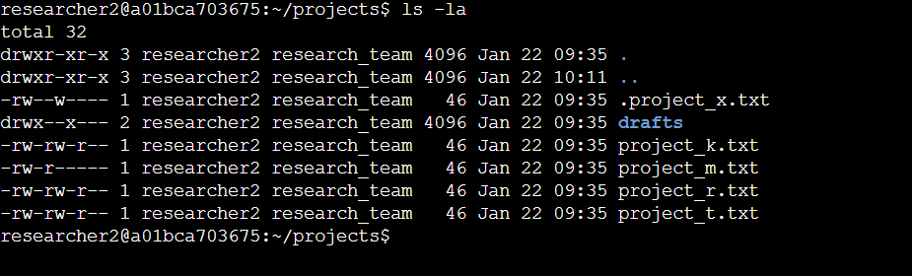

To view the permission of hidden files ls -la command will be used .In the above .project_x.txt is the hidden file.

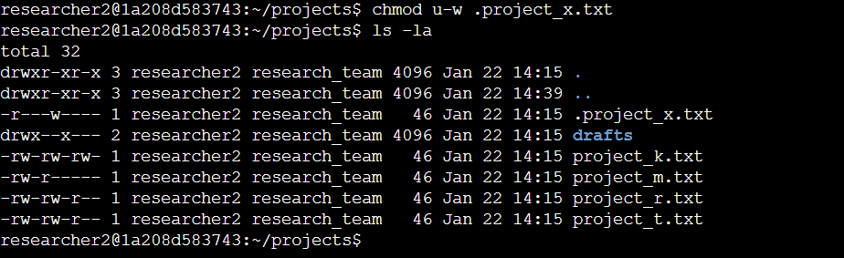

Changing the access permission of hidden file is similar to non-hidden file just we need include a dot”.” Before the file name

chmod u-w .project_x.txt

## Change directory permissions

First, we will check the group permissions of the /home/researcher2/projects/drafts directory and then modify the permissions as required.

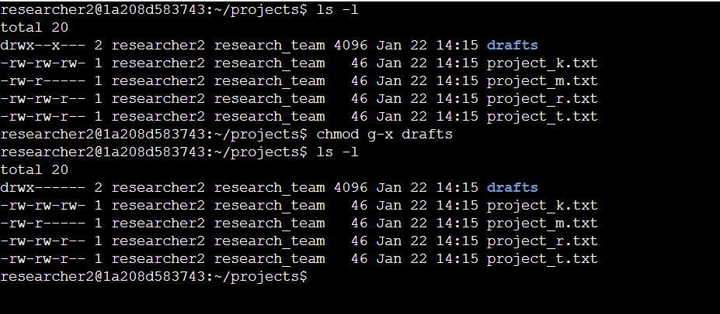

## 

In the above we remove the executable file access to draft chmod g-x drafts

## Summary

I have changed the access permission of different owner according to the security need. In general the first step is to list the permission using ls -l ,then we can modify or update the access permission by using chmod command according to need.